**Worksheet**

1. **What are the LCMs of these numbers?**

a) 7 and 15 …………………………………………………………………………………………..

b) 6 and 21 …………………………………………………………………………………………..

c) 4, 5 and 8 …………………………………………………………………………………………

1. **What are the HCFs of these numbers?**

a) 16 and 44 …………………..……………………………………………………………………..

b) 112 and 35 ………………………………………………………………………………………..

c) 16, 30 and 42 ...……………………………………………………………………………………

**3. Fill in these prime factor decomposition tables.**

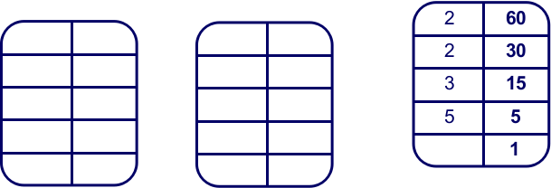 **Example**

a) b)

**60 = 2 × 2 × 3 × 5**

c) Write 210 as a product of prime numbers:

210 = …………………………………………….

d) Write 36 as a product of prime numbers:

36 = ………………………………………………….

**4.** **Draw lines linking the numbers with their corresponding prime factor products.**

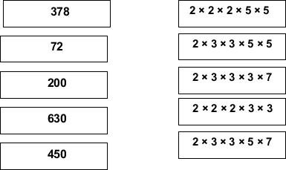

**5. Use this Venn diagram to work out the LCM and HCF of 175 and 30.**

Remember; put the prime factors of 175 in the first circle, and factors that are common to both 175 and 30 in the overlapping section. Put the prime factors of 30 in the second circle.

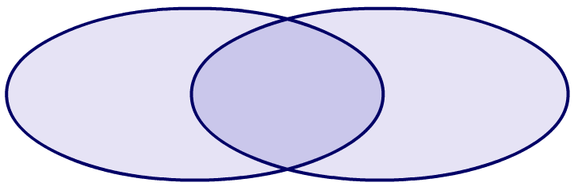

30

LCM = ………………………. HCF = ……………………………….

**6. It takes Sam 5 minutes to run round a lap of the park and it takes Natasha 7 minutes.**

1. How long will it be before both Sam and Natasha meet at the starting point?

…………………………………………………………………………………………………

b) How many laps will each of them have completed?

……………………………………………………………………………………………